THE HEBREW TEACHER
By Maya Arad
Translated from the Hebrew by Jessica Cohen

A Reading Group Guide

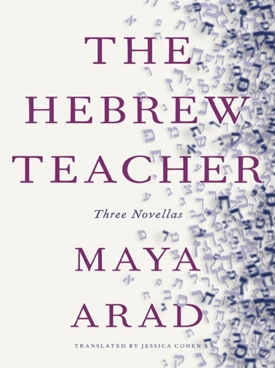

The Hebrew Teacher

- The novella opens with Ilana writing “It wasn’t a good time for Hebrew.” Is she thinking of the low enrollment for Hebrew classes, or are there other ways in which this is not a good time for Hebrew? Why does Ilana think that the early 1970s were a good time for Hebrew? How have things changed since?

- “Young Jews in America are sick of your generation, which defends Israel at any cost no matter what it does,” Ilana’s son Barak tells her. As Ilana reflects on her career teaching Hebrew and as she feuds with new Hebrew literature professor Yoad, how do generational differences manifest themselves? How have views about Israel and the Israel-Palestine conflict changed throughout Ilana’s time at the college?

- Ilana and Yoad have very different political views, but there are many other differences between them: they differ in their view of the diaspora, their relation to the Midwest, their idea of the role of a Jewish Studies professor. How do these differences shape their relationship and lead to Ilana losing her position at the end of the story? Do you think Yoad is the villain in this story, or does it take two to tango? Did Ilana also contribute to the souring of their relationship?

A Visit (Scenes)

- Why do you think Arad chose to use multiple voices in this story and to format the novella in scenes? How do the three different viewpoints contribute to the story?

- Miriam is delighted when Ravit gifts her an album of pictures of her grandson Yonatan. Why are the photographs of Yonatan, and her album for her son Yoram, so important to Miriam?

- Picking his mother up from the airport at the beginning of her visit, Yoram cannot bring himself to call her Ima, Mom. At the end of the story, as Yoram wakes in his hospital bed, he finally calls her Ima. How and why does Yoram’s illness change his relationship with his mother?

- What are of Malka and Ravit’s roles in the story? Why do you think the author included them?

Make New Friends

- Efrat is worried about the effect access to social media will have on her daughter Libby’s social life. Do you think social media helps or hurts Libby? Do the risks outweigh the potential benefits?

- Efrat is determined to help her daughter become more popular and make some friends. What do you think Efrat’s motivation is, and what does it reveal about her own difficulties? Do you think any of her actions are inappropriate?

- How do Libby’s struggles affect the relationship between Efrat and her husband Benny? What are their views on Libby’s weight gain, participation in family life, and social media use? Whose views do you agree with?

- Efrat grew up in Israel and doesn’t know how American middle schools work. She’s also not familiar with the social media that Libby’s friends are using. How do these two factors, immigration and technology, affect the generation gap between Efrat and her daughter?

- Consider the name of the novella, Make New Friends. Who do you think it refers to? Libby? Efrat?

Final thoughts

- Immigration from Israel to the US is a common thread running through all three novellas. How did immigration affect the life of the three protagonists, Ilana, Miriam and Efrat? How did it shape their professional lives, and their relationship with their families and, specifically, their children?

For more information about The Hebrew Teacher and other books, please visit www.newvesselpress.com.

